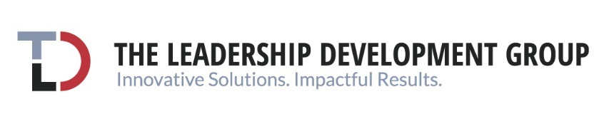

FOR IMMEDIATE RELEASE:
For further information, contact:
Amy Riemer, Media Relations
978-502-4895
amy@riemercommunications.com

THE LEADERSHIP DEVELOPMENT GROUP ANNOUNCES TOP INDUSTRY TRENDS FOR LEADERS ACROSS THE HEALTH ECOSYSTEM
New Study Uncovers Current Healthcare Trends and Provides Solutions for Leaders

NEW YORK, NY June 17, 2024 – For leaders across the health ecosystem, accelerating innovation, embracing AI, and driving M&A activities are crucial for success today. These are some of the important industry trends The Leadership Development Group (TLD Group), a global talent development firm, report on in their new report What It Takes to Lead Across the Health Ecosystem - Top Industry Trends & Solutions for Developing Leaders Today. TLD Group reports on the critical challenges impacting health ecosystem leaders today, including artificial intelligence, health equity, mental health, M&A activities, and provides talent development solutions aimed at building leaders’ ability to respond to change. To download the report, click here.

“Our insights are based on our work with influential leaders and organizations across the health ecosystem, the most frequently received requests for leadership development from our clients, and observations from research and news related to the health ecosystem and the leadership development industry,” explained Tracy Duberman, PhD, President and CEO of The Leadership Development (TLD) Group. “Our comprehensive guide provides insights and tools needed to lead effectively in a rapidly changing landscape, including key trends shaping healthcare leadership, practical strategies to build leadership capacity, wisdom from top leaders and organizations, and detailed recommendations based on the latest industry research.”

Below are the Top Eight Health Ecosystem Trends and Development Strategies Detailed in the Report:
- Artificial Intelligence: Embrace AI and explore new ways that technology can be integrated into existing processes and tools.
- Health Equity: Focus on “equity,” reduce disparity, and create opportunities for all people to attain their highest level of health.
- M&A Activities: Collaborate to improve outcomes and bottom-line performance.
- Mental Health and Well-being: Embrace mental health as a core component of health & wellness.
- Employee Sustainability: Create value for individuals, enhancing skills and employability, and connecting to purpose.
- Empowering the Workforce: Empower the workforce and rethink how to lead.
- Diversity, Equity, and Inclusion (DEI): Create diverse leadership teams reflecting the patient populations and workforce.
- Work-Life Integration: Create work environments that allow people with different beliefs to work collaboratively.
“As a health ecosystem talent development firm, we make it a priority to stay up to date on the latest industry trends. By doing so, we are continuously aligning our talent development support to current challenges allowing us to prepare the leaders, teams, and organizations that we work with to make well-informed and research-driven decisions in their workplace and beyond,” said Duberman.
The Leadership Development Group is a global coaching and talent development consulting firm. Through its customized leadership solutions, TLD Group ignites leaders, teams, and organizations to align their passion to purpose to transform the healthcare industry. TLD Group works with the most influential players in the industry --- providers, payers, health systems, pharmaceutical companies, policymakers, health-adjacent, and those looking to disrupt. TLD Group’s talent development solutions create leaders who are collaborative change agents capable of executing mission-critical organizational strategies.

# # #

